**Problem Statement 1: Automate YouTube: Telegram Challenge**

New videos being uploaded by any specific YouTube channel and want to send a notification on Telegram group and make an excel sheet for the sales team.

**Solution →**

Step 1 : Understanding

Requirements:

IFTTT Account,

YouTube App and Its Account,

Telegram App and Its Account,

Sign in Google Excel sheets

Step 2 : Ideating

We need to Connect YouTube Channel and Telegram Applet through IFTTT by giving Channel ID.

Step 3 : Implementing

Open IFTTT website Click on create. And Add as shown below.

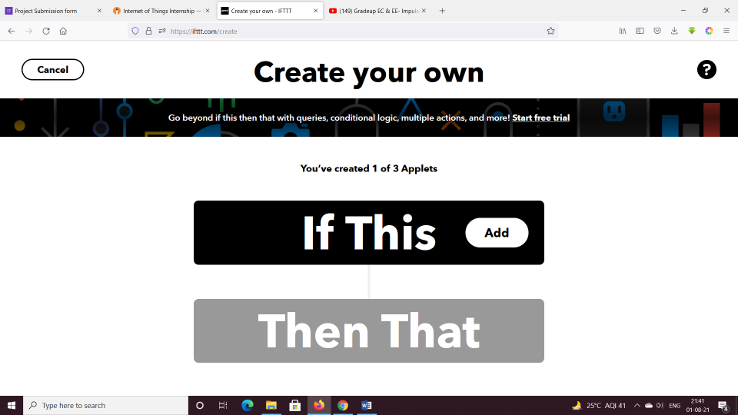

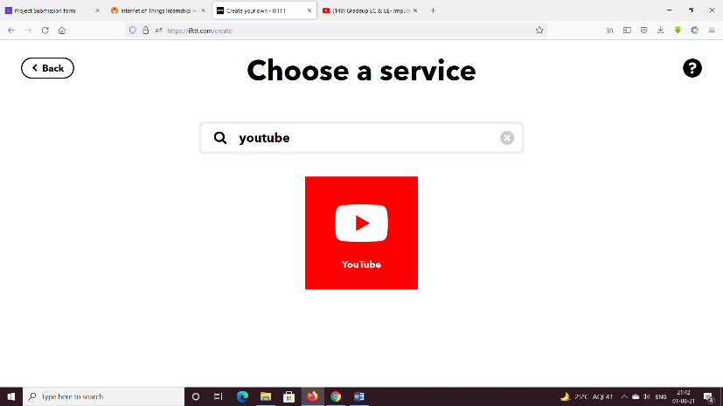

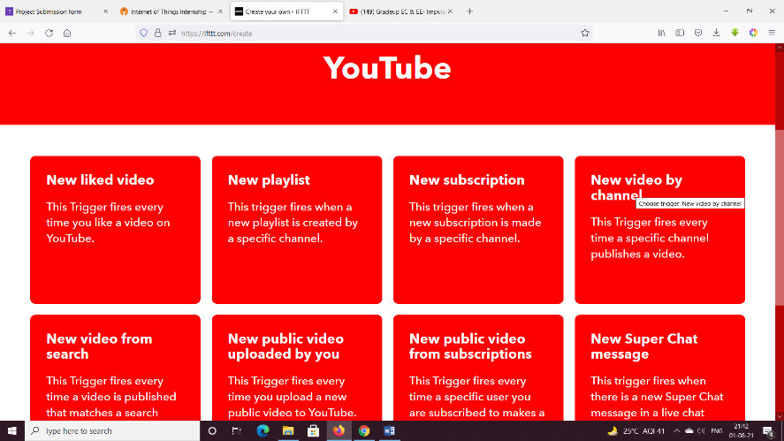

Search channel and Copy channel ID.

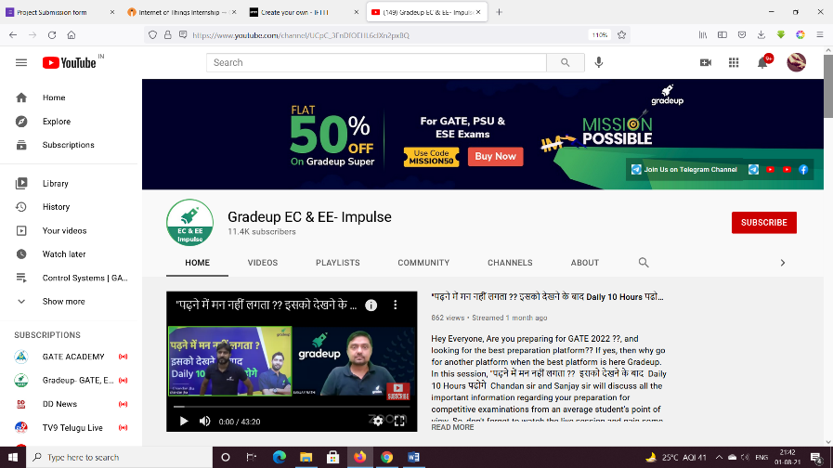

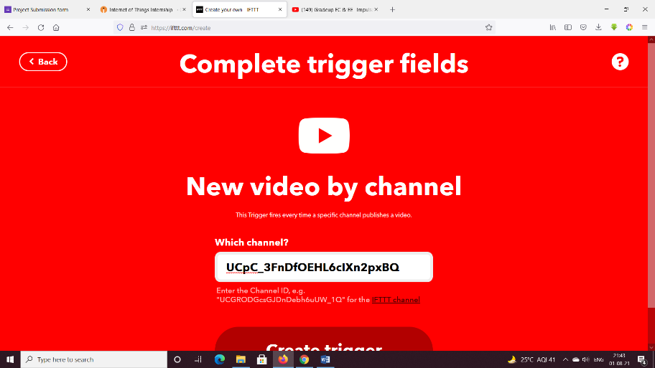

Add Action in Then That block.

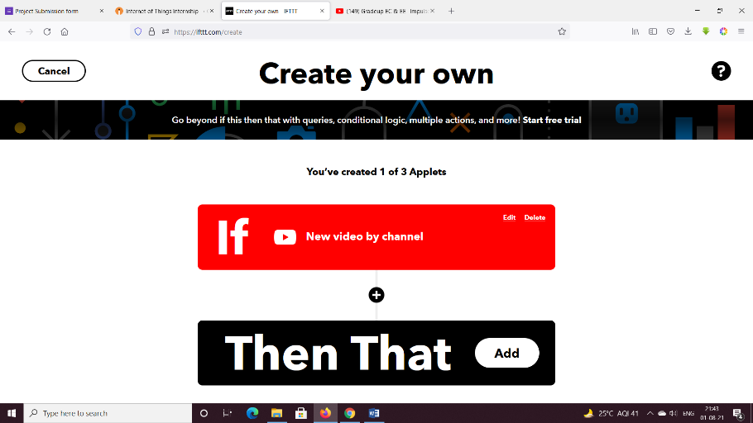

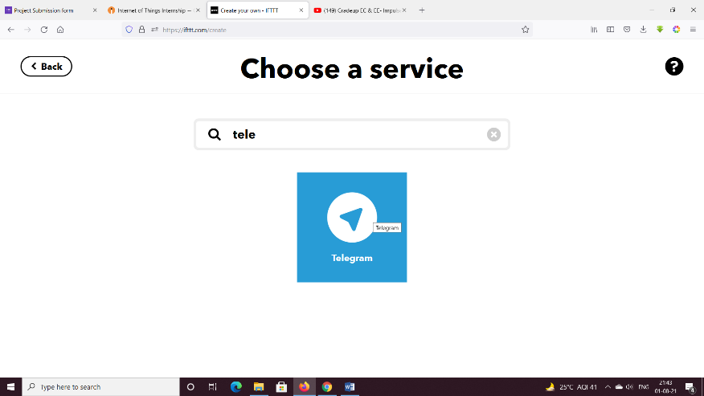

Select send a message.

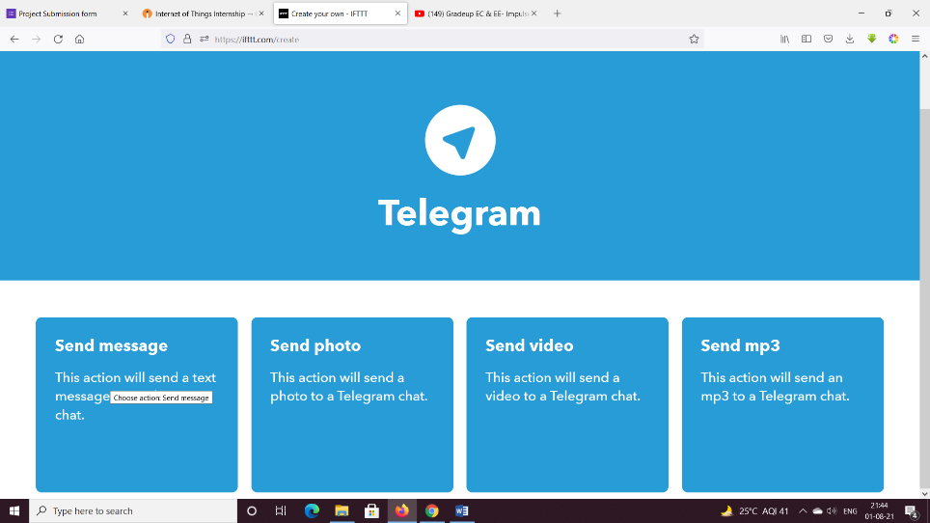

Click on Connect.

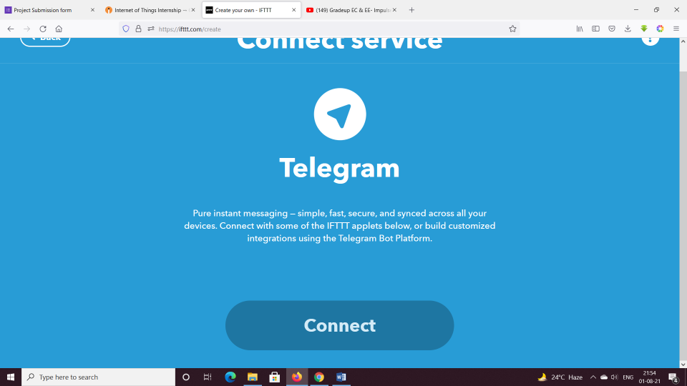

Create Action.

Click on Finish.

Stay Connected.

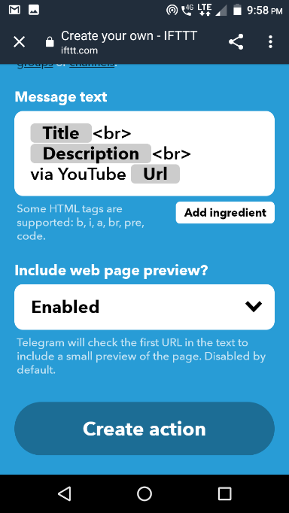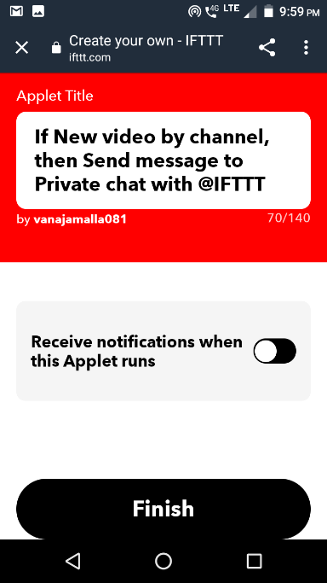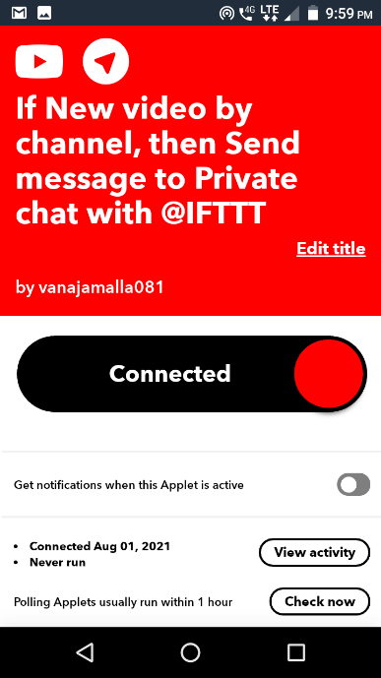

Step 4: Final check

Notification as Follows

